Note: Include this page only when adding / amending / deleting a document. If using this document as a record, this Revision History page can be omitted.

REVISION HISTORY

Revision no | Date | Description of Changes | Reason for Revision | Revised by | Approved by
0 | 20Jun12 | Add Revision History to all documents | Recommendation from Stage 2 audit | CMRojas
1 | 8 Apr 16 | Added disclaimer when printing the document | For document control | RCGanal | MVBergantin
TM-BR-MG-11 Rev02, 10302015

I. Objective
To ensure maintenance of cleanliness and orderliness of the office vicinity all the time and to ensure that office equipment are working properly.
II. Scope
This procedure defines the action and responsibilities of the Office Aide and Custodial Staff in maintaining the cleanliness and orderliness of the office. The output of both is monitored and supervised by the Administrative Assistant. This covers activities from the adherence to the schedule to the completion of the report. Tasks Schedule is also given.
III. Definition of Terms
Checklist of Tasks Schedule | - It contains the specific tasks, assigned area and the schedule of performing the tasks related to maintaining the office.  - It will be prepared by the Custodial Staff and Office Aide and will be checked by the Custodial Staff and Office Aide when they completed their tasks and it will be validated by the Administrative Assistant by conducting random check.  - It is submitted every 1st and 16th day of the month.
Admin Report | - It reports occurrences and issues related to office maintenance (i.e. but not limited to replacement of lost or worn-out items, re-construction of broken item and purchase of an item for office beautification)  - It is submitted to ExeCom every Monday.

IV. Procedure Details
RESPONSIBLE | ACTIVITY | INTERFACE
Office Aide Custodial Staff  Administrative Assistant | 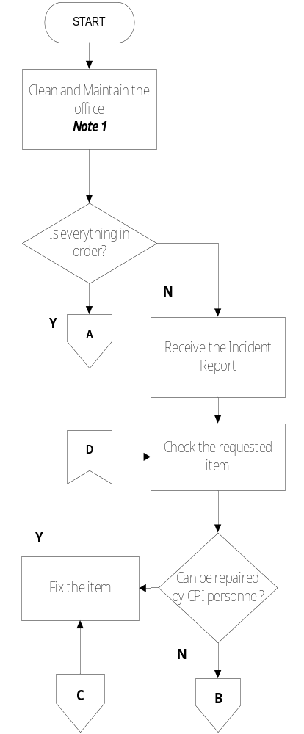 | Checklist of Tasks Schedule  Custodial Staff Office Aide  Incident Report Internal Clients  Guidelines for Repairs
RESPONSIBLE | ACTIVITY | INTERFACE
Administrative Assistant | 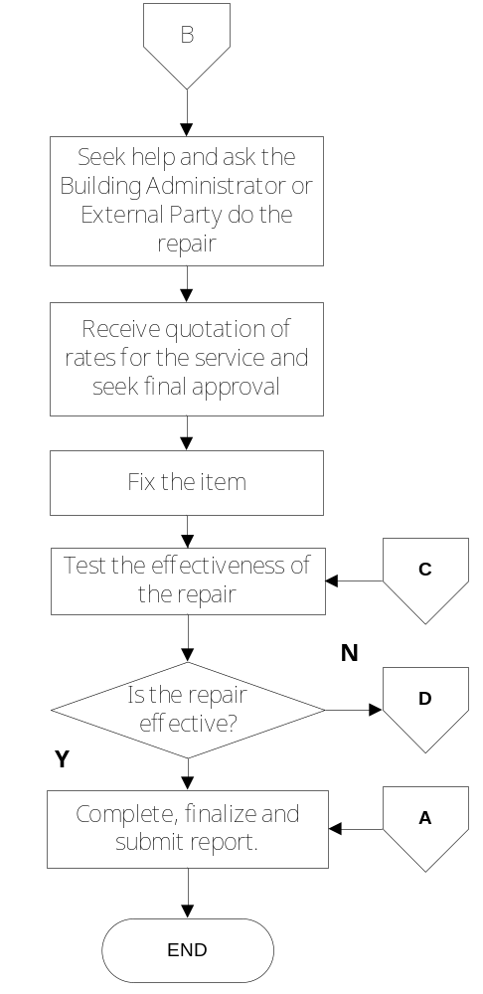 | Building Administrator External Party Guidelines for Repairs  Building Administrator External Party Quotation ExeCom  Incident Summary Report  Admin Report

Notes:
- See Checklist of Tasks Schedule.

V. References
- Checklist of Tasks Schedule
- Guidelines for Repairs

VI. Quality Records
- Accomplished Checklist of Tasks Schedule
- Incident Report
- Incident Summary Report
- Admin Report

